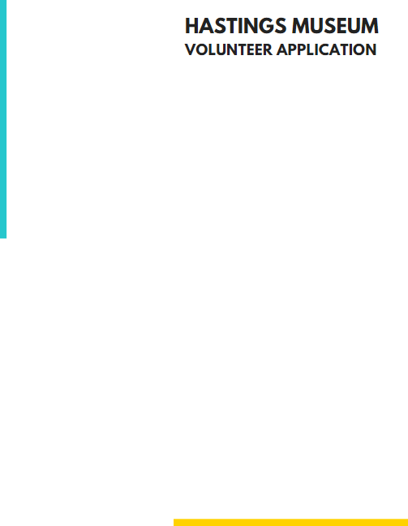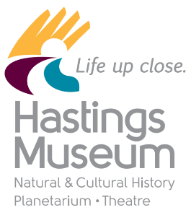

The Hastings Museum loves its volunteers! Volunteers play an important role in creating a unique community of individuals whom share a passion for natural and cultural history, aid in supporting the museum, contributing to the visitor experience and best of all- giving back to the community. The Hastings Museum welcomes volunteers from all facets of the community.

**Requirements:**

* Volunteers must be at least 12 years of age
* All volunteers must pass a background check
* Able to attend a brief orientation and future trainings

As policy, the Hastings Museum **does not accept volunteers who are fulfilling court ordered community service** for the following reasons:

1. The court requires individuals fulfilling court ordered community service to be supervised and Hastings Museum volunteers often work unsupervised.

2. The Museum often works with minors who are unaccompanied by a parent or guardian.

3. The Museum houses numerous artifacts, exhibits, and equipment of great value.

**Areas of Volunteering:**

**Marketing Department**

* Volunteers can distribute museum rack cards, flyers and posters to area businesses.

# Education Department

* Volunteers provide assistance with education programs for school groups, Scouts, and public programs. Some tasks include preparing activity and craft examples, reading to students, and helping students with activities and crafts.

# Special Events

* Volunteers may participate in special events at the Museum by serving food, assisting visitors, leading learning stations and as exhibit docents.

**Benefits of being a Hastings Museum Volunteer include:**

* Free Museum Membership for Volunteer & Museum Store Discounts **\***
* Free Volunteer Swag **\***
* Free Admission to Theatre Previews
* Free Admission to the Museum during National Volunteer Week
* The opportunity to meet others that share like interests

**\*** To obtain this benefit, volunteers must complete

50 hours of volunteer work in one calendar year.



Application Date: ____________________ Volunteer Start Date: __________________

(Official use only)

## **PERSONAL INFORMATION**

Name: _____________________________________________________ Date of Birth: ___________________

(Month, Day, Year)

Address: ______________________________________

City, State: ______________________________________

Zip Code: **______________________________________**

Home Phone: ___________________________________ Cell Phone: _________________________________

Email Address: _____________________________________________________________________________________________

*Note: Please include an email you will check often. If a parent or guardian would like to receive the emails as well, include their email address.*

## **EMERGENCY CONTACT**

If you would be a Junior Volunteer (between ages 12-18), please list a parent or guardian as one of your contacts.

1. Primary emergency contact person: ____________________________________________________________________

Relationship: ________________________ Phone: _____________________________________

1. Secondary emergency contact person: _________________________________________________________________

Relationship: ________________________ Phone: ____________________________________

## **REFERENCES**

Please list 2 non-family adult reference.

1. Name: ___________________________________ Phone: _______________________________________

E-mail Address: _______________________________________________________________________________

1. Name: ___________________________________ Phone: _______________________________________

E-mail Address: _______________________________________________________________________________

## 

## **TYPE OF VOLUNTEER WORK**

Please circle what type of volunteer work are you interested in. (For more details of each area, see front page of this application.)

Marketing Education Special Events All Areas

**AVAILABILITY**

SUN MON TUE WED THU FRI SAT

Morning

Afternoon

Evenings

Have you volunteered before? ( ) Yes, where? _______________________________________ ( ) No

Are you applying because of a Court-order community service requirement?  (   ) Yes   (    ) No

*Note: If you answered “yes” to this question, you are unable to complete your service hours at the Museum.*

If age 65 or older, are you a part of the Senior Corps Volunteer program: ( ) Yes ( ) No

Do you have reliable transportation in getting to the Museum? ( ) Yes ( ) No

Do you understand that this volunteer position is a NON-PAID position, but has similar expectations as professional employment? ( ) Yes ( ) No

**Please Note:**

1) While every effort will be made to find a task for every willing volunteer, the Museum will not guarantee that all volunteers can be matched to a volunteer activity.

2) The Museum does not accept volunteers who are fulfilling court ordered community service. See front page of this application for more information on this.

**Signature: ____________________________________________________ Date: ____________________________**

*\* If under 18 years of age, a Parent/Guardian needs to do the signature.*

**Return Application to:**

Katie Karr | Education Assistant | Volunteer Coordinator Hastings Museum

* In Person: 1330 N Burlington Ave., Hastings, NE 68901
* Online: kkarr@cityofhastings.org

Within a week of submitting your application, an email will be sent out to set up an orientation time. If you do not receive this email, please contact Katie about your application status.

**Return Application to:**

Katie Karr | Education Assistant | Volunteer Coordinator Hastings Museum

* In Person: 1330 N Burlington Ave., Hastings, NE 68901
* Online: [kkarr@hastingsmuseum.org](mailto:kkarr@hastingsmuseum.org)

Within a week of submitting your application, an email will be sent out to set up an orientation time. If you do not receive this email, please contact Katie about your application status.